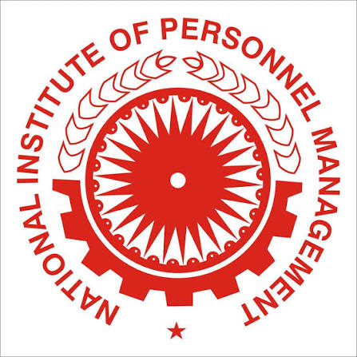 | NIPM - WESTERN REGIONAL CONFERENCE (WRC) 2026  Hosted by NIPM Sahyadri (Satara) Chapter  CALL FOR PAPERS & ARTICLES  Theme: "HR Kaleidoscope: Shaping Human Capital journey towards Bharat @ 100" |  | 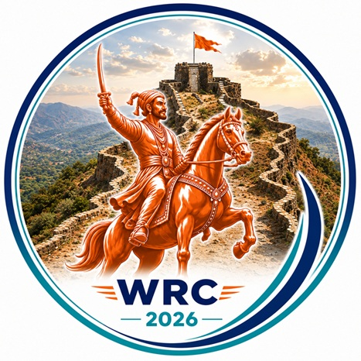
📅 Saturday, 10 October 2026 |  | 📍 Late Yashwantrao Chavan Auditorium, Behind ZP Office, Satara

INVITATION OVERVIEW
The National Institute of Personnel Management (NIPM), India's apex body for HR management, is committed to promoting excellence in people practices, competence, and ethical leadership. Adapting to technological shifts and evolving employee expectations, NIPM continues to meet the aspirations of today's HR community.
The NIPM - Sahyadri (Satara) Chapter is hosting the Western Regional Conference on October 10, 2026. On the occasion of, the chapter is inviting Human Resource practitioners, corporate leaders, legal and Industrial Relations experts, researchers, and academicians to submit original articles, case studies, and perspective papers for the official commemorative souvenir. The souvenir will be formally unveiled during the inaugural session of the conference before an audience of CXOs, senior HR professionals, policymakers, academicians and industry delegates from across the region.
CORE TRACKS & TOPICS
Track 1 — Technology Lens (AI & Digital HR)  Focus: Human-in-the-Loop: blending smart AI automation with human empathy.  Angles: AI in HR to add value; Industry 4.0 → 5.0. | Track 2 — People Lens (Diverse Workforce)  Focus: Generations at Work: trust, psychological safety & collaboration between Gen Z and leadership.  Angles: Cross-gen mentorship; Gen-Z aspirations; emerging HR leadership trends.
Track 3 — Leadership Lens (Growing Together)  Focus: IR 2.0 & Labour Codes: modernising compliance and Board alignment.  Angles: Operationalising Labour Codes; proactive IR partnerships; HR competencies for Bharat @ 100. | Track 4 — Capability Lens (Skilling for Future)  Focus: Next-Gen L&D: bridging skill gaps via micro-learning and AR/VR.  Angles: AR/VR safety drills; personalised competency frameworks; rapid reskilling.
SUBMISSION GUIDELINES
- Length: 1,200–1,500 words | Format: .doc/.docx, Times New Roman/Arial, 11–12 pt, 1.15 spacing
- Author details: Full name, designation, organization, official email, bio (max 60 words), high-res passport photo (min 300 DPI)
- Content: pragmatic insights, actionable frameworks or real-world case studies — original & plagiarism-free, with a signed Zero Percent Plagiarism Report
- Registration fee: ₹ 5,900/- per article (non-refundable, incl. GST) — pay to account below & share payment proof with the article.
  Account Name | National Institute of Personnel Management
  Bank | State Bank of India, Park Circus Branch, Kolkata
  IFSC Code | SBIN0001749
  A/c No. (Current) | 10513447918
  Abstract Due | 28 August 2026
  Full Article Due | 15 September 2026
  Acceptance Notice | 25 September 2026
  Official Release | Inaugural Ceremony, NIPM WRC 2026 – Satara
SUBMISSION PROCEDURE
- Email: nipmsatara.souvenir@gmail.com | Subject: Article Submission - NIPM WRC Satara 2026 - [Author Name] - [Track No.]
- Queries: Jagannath Kamble — 9096358943
SELECTION CRITERIA
Selection rests solely with the Editorial/Selection Committee; no reasons for rejection will be provided. The Committee's decision is final and binding on all authors/participants.
NIPM - Sahyadri (Satara) Chapter | Join us in shaping the Human Capital journey towards Viksit Bharat @ 100

